**Migrating Content**

This relates to the migration of regular web page content (i.e. About Us, Patients & Visitors, Careers), not dynamic content (i.e. Physicians, Services, Department).

**Review Website Inventory**

Prior to handing website content directly, review the website inventory spreadsheet for the section to be migrated. In the website inventory spreadsheet or in a new spreadsheet, identify and label the three different types of content:

1. Content to migrate: page will be moved over directly
2. Content to redirect: page will be added to the Redirects spreadsheet
3. Content to review: page will be evaluated by marketing director or another team member

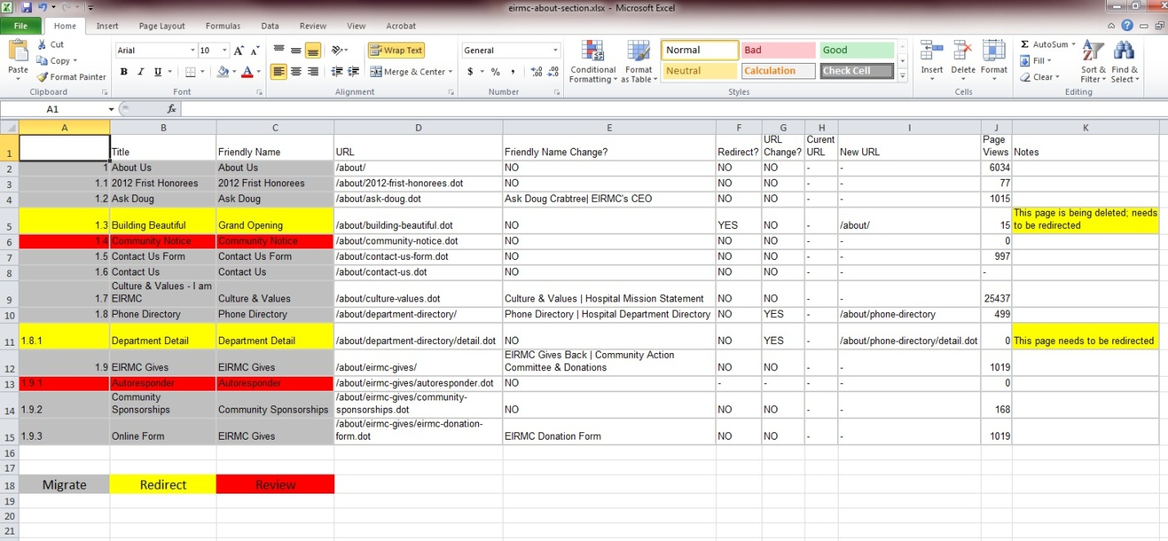

*Example of a website inventory review spreadsheet for the About section with content labeled as migrate (gray), redirect (yellow), or review (red)*

**Prepare Content for dotCMS**

|  |  |
| --- | --- |
| Once the content has been reviewed, prepare it to be migrated into dotCMS. Add the pages to be redirected to the Redirects spreadsheet, or send them to the SEO Strategist. Send the pages that need further evaluation to the marketing director or another team member. Follow these steps for pages that will be migrated: | |
| 1. **Copy Source Code**   Locate and highlight the page copy to migrate. In Firefox, right-click and select View Selection Source. When the pop-up screen appears, make sure all of the page content is selected and then copy it. | |
| *In Firefox, highlight the content, right-click, and select view selection source* | *Copy source code from pop-up screen* |
| 1. **Paste into Editor**   After copying the source code, paste it into your editor. | *Paste code into editor* |
| 1. **Adjust Code to Web Standards**   Before adding the code into dotCMS, check for these errors:   * Syntax Errors   + Correct uppercase code: <P>This is some text.</P> 🡪 <p>This is some text.</p>   + Replace <b></b> and <i></i> tags with <strong></strong> and <em></em> tags   + Remove any non-breaking spaces: &nbsp;   + Add any special character/entity codes: &ldquo; &trade; &amp;   + Correct image paths: <img src=“/dotAsset/…”> 🡪 <img src=“/util/images/…” />   + Remove inline styles   + Remove/Fix other deprecated code * Formatting Errors   + Ensure headers are in correct order: <h1>, <h2>, <h3>, etc.   + Add white space and indentation where necessary   + Fix headers wrapped in <p> tags: <p><b>Head</b></p> 🡪 <h1>Head</h1>   + Fix lists wrapped in <p> tags: <p>1. Item</p> 🡪 <ul><li>Item</li></ul>   + Move contact, learn more, news, videos, and other CTA content to the sidebar   + Add code elements from the [migrator toolbox](http://hospital-pro.prod.ehc.com/toolkit/migration-toolkit/migration-code-helpers.dot) where appropriate * Other Errors   + Omission of alt text (alt text should accompany every image)   + Broken links (review all links as many of them will change during migration)   + PDFs missing size and icon information (add size and icon info for usability)   + Smart quotes, m-dashes and n-dashes will need to be replaced. dotCMS does not interpret these character correctly. | |
| *Identify incorrect code* | *Adjust code to web standards* |
| 1. **Move Files**   After you have corrected the code, download all images, documents, and other files. Upload these into the correct folder on the host (i.e. /util/images/, /util/documents/, etc.) | |

**Add Content to dotCMS**

After the content has been adjusted to web standards, add it to dotCMS by following these steps:

1. Review the naming conventions spreadsheet for the section being migrated.
2. Create folders and pages according to the standards in the naming conventions spreadsheet.
3. Review the website inventory spreadsheet.
4. Add the correct page property information according to the standards and corrections indicated in the website inventory spreadsheet.
5. In page properties, select a template from our library of HUT Templates.

When in the template field, click on the down arrow. You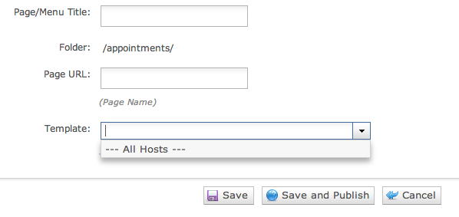 will see a drop down that says ‘All Hosts’. Select ‘All Hosts’ in order to see all available templates. Type ‘fw’ into the Template field and a list of available templates will populate the dropdown. In most cases you need to use the templates with ‘Hospital Unified Template’. Eventually there will be more templates for HUT.

* 1. **fw Hospital Unified Template – Interior**
  2. **core.ehc.com fw Hospital Unified Template – Homepage**
  3. core.ehc.com fw Page No Asides
  4. core.ehc.com fw Page Aside Left
  5. core.ehc.com fw Page Aside Right
  6. core.ehc.com fw Page Split Asides
  7. core.ehc.com fw Two Asides Left
  8. core.ehc.com fw Two Asides Right
  9. core.ehc.com fw Three Even Sections

1. Once the page is created, add main content to the center container and sidebar content to the aside container.
2. Publish the page in dotCMS and check for errors in a web browser.